Embedded Software Development &  
Embedded Product Design:   
Design paper

Magnus Mortensen, Nicolas Munafo - Shanghai Polytechnic University, 2019/12

# Embedded Software Development

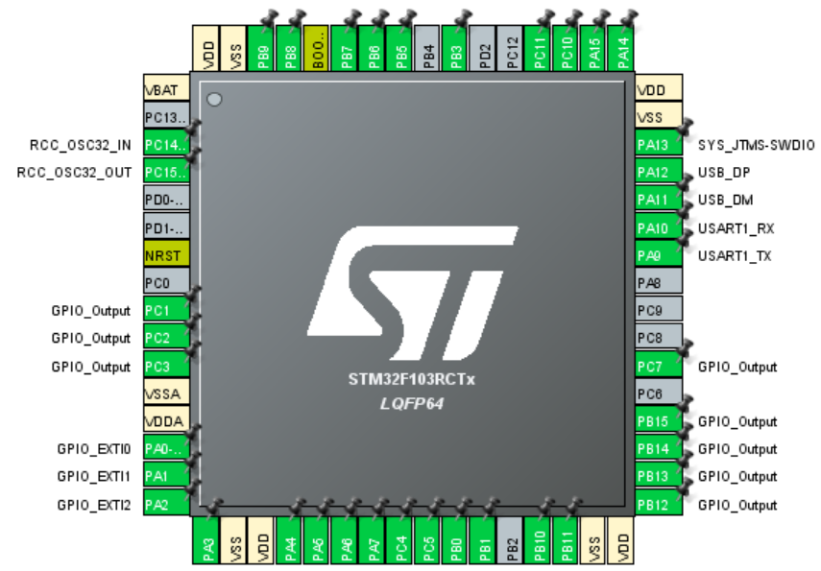

The first part was configuring a virtual CPU identical to the one on our board, namely a STM32F103RCTx. For this we used the software STM32CubeMX. We went through the CPU ports and designated each with the function we desired. For this we referred to the board schematics provided to us by the professor. Keeping the final requirements in mind we finetuned each port’s parameters. When the CPU was configured, we used STM32CubeMX to generate the template code which would eventually run on the actual board, the operating system.